4 ram

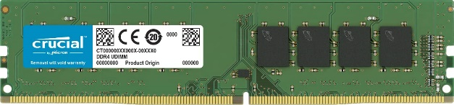

Inner image

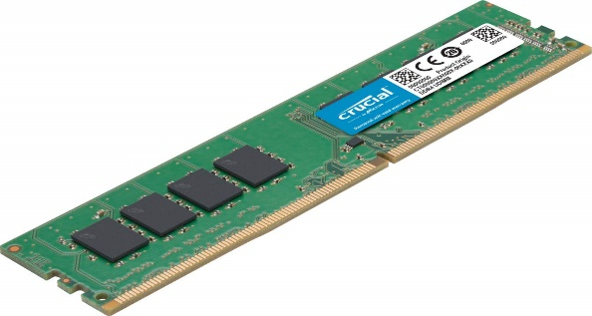

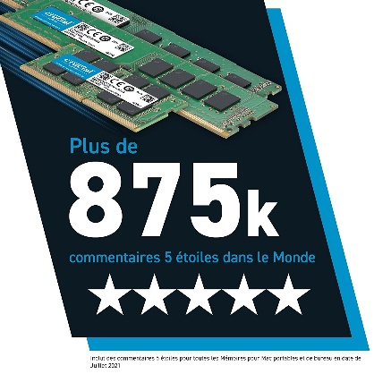

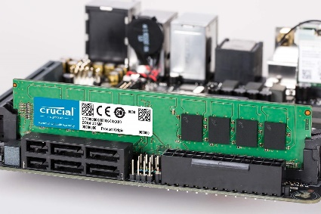

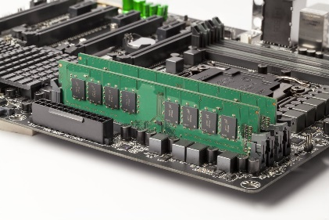



Crucial RAM 4GB DDR4 2666 MHz CL19 Desktop Memory CT4G4DFS8266

|  |  |
| --- | --- |
| M.R.P.: | ₹2,800.00₹2,800.00 |
| Deal of the Day: | ₹1,199.00₹1,199.00 |

**Product details**

|  |  |
| --- | --- |
| **Brand** | Crucial |
| **Computer Memory Size** | 4 GB |
| **RAM Memory Technology** | DDR4 |
| **Memory Speed** | 2666 MHz |
| **Compatible Devices** | Desktop |
| **Special Feature** | Memory Standard: DDR4-2666/PC4-21300 |

* 4GB, DDR4 RAM
* Memory Speed-2666MHz /PC4-21300 (2666MHz). CAS latency - 19
* ECC Type = Non-ECC, Form Factor = UDIMM, Pin Count = 288-pin, PC Speed = PC4-21300, Voltage = 1.2V, Rank and Configuration = 1Rx8
* Improve your system's responsiveness, run apps faster and multitask with ease
* Install with ease; no computer skills required How-to guides available at Crucial
* Compatibility assurance when using the Crucial System Scanner or Crucial Advisor Tool
* Crucial 10-year limited warranty
* Country of Origin: United States.
* For technical Support : call on- 1800 425 3234
* 4GB, DDR4 RAM
* Memory Speed-2666MHz /PC4-21300 (2666MHz). CAS latency - 19
* ECC Type = Non-ECC, Form Factor = UDIMM, Pin Count = 288-pin, PC Speed = PC4-21300, Voltage = 1.2V, Rank and Configuration = 1Rx8
* Improve your system's responsiveness, run apps faster and multitask with ease
* Install with ease; no computer skills required How-to guides available at Crucial
* Compatibility assurance when using the Crucial System Scanner or Crucial Advisor Tool
* Crucial 10-year limited warranty
* Country of Origin: United States.
* For technical Support : call on- 1800 425 3234
* In an unlikely case of product quality related issue, we may ask you to reach out to brand’s customer service support and seek resolution. We will require brand proof of issue to process replacement request.